CS-360-T5539 Mobile Architect & Programming 23EW5

4-4 Assignment- UI Design

Jacob Simmons, 28 May 2023

**UI Screen**

The chosen app for suggested improvements is the AT&T app, specifically the "Bill and Pay" screen. The key features and functional that need to be maintained are listed below. Also the suggested changes are listed below for the new interface.

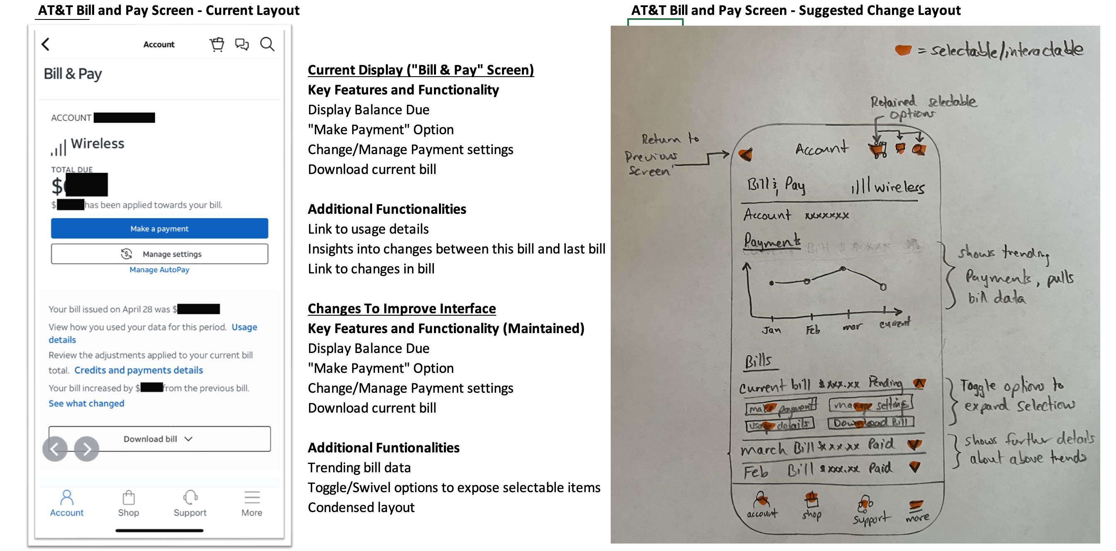

**Design Best Practice & Justification**

The best practice design changes are built around improving visualizations where possible. According to (“Material Components,” n.d.) " Selection components let people specify choices" and this is the reason that the addition of the toggle/swivel switches are added. These allow for a condensed view while allowing the user to select additional details if needed based on the above trends in their monthly wireless bill.

Another design choice was to improve the visualization with the addition of a graph, According to (“Material Components,” n.d.) "Communication components provide helpful information." It is with this that the addition of the trending graph provides key details about the performance of the billing details for the user this can allow them to make key choices about their usage and plan. This information would have been available previously to the user but only after multiple sections. This layout provides a quicker way for the user to gain key information without having to experience more loading pages.

**References**

Material Components. (n.d.). Android Developers. https://developer.android.com/design/ui/mobile/guides/components/material-overview